**Lab 1**

* Create teams (2 or 3 students/team)
* The lab instructor will assign a problem for Lab 2-4 to each team (see  *lab problems*  and *lab requirements*)
* You should work on your own laptops this semester; the students who do not own a laptop will let the lab instructor know about this; the lab instructor will prepare workstations for them (in the following weeks)
* Install JDK 8 (or higher)
* Install IntelliJ IDEA Ultimate
* Install Git
* Create a “Hello World!” application in IntelliJ IDEA using Git. Get familiar with basic Git commands.

------------------------------------------------------------------------------------------------------------------------------

Creating a Git repository (on [**Bitbucket**](https://bitbucket.org)); everything has to be be **private**!!!

* one of the team members (S1) will prepare a git repository
  + create a team and give a name (in examples I used “sdi_test_team”)

|  |  |
| --- | --- |
|  |  |

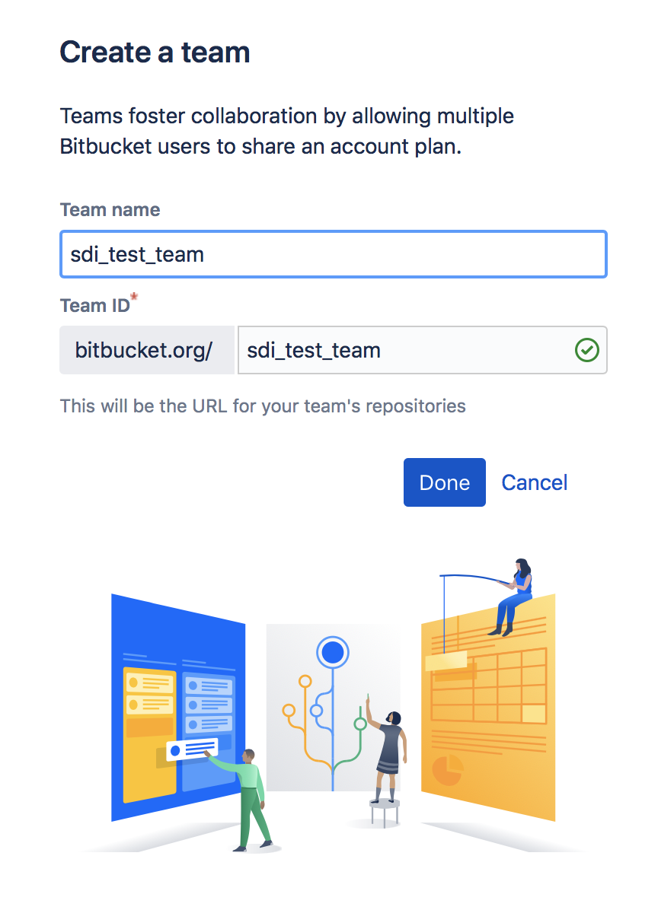

* + create a project (be sure that the owner is the team you want; the project should be **private**! for project name I used “test_project”)

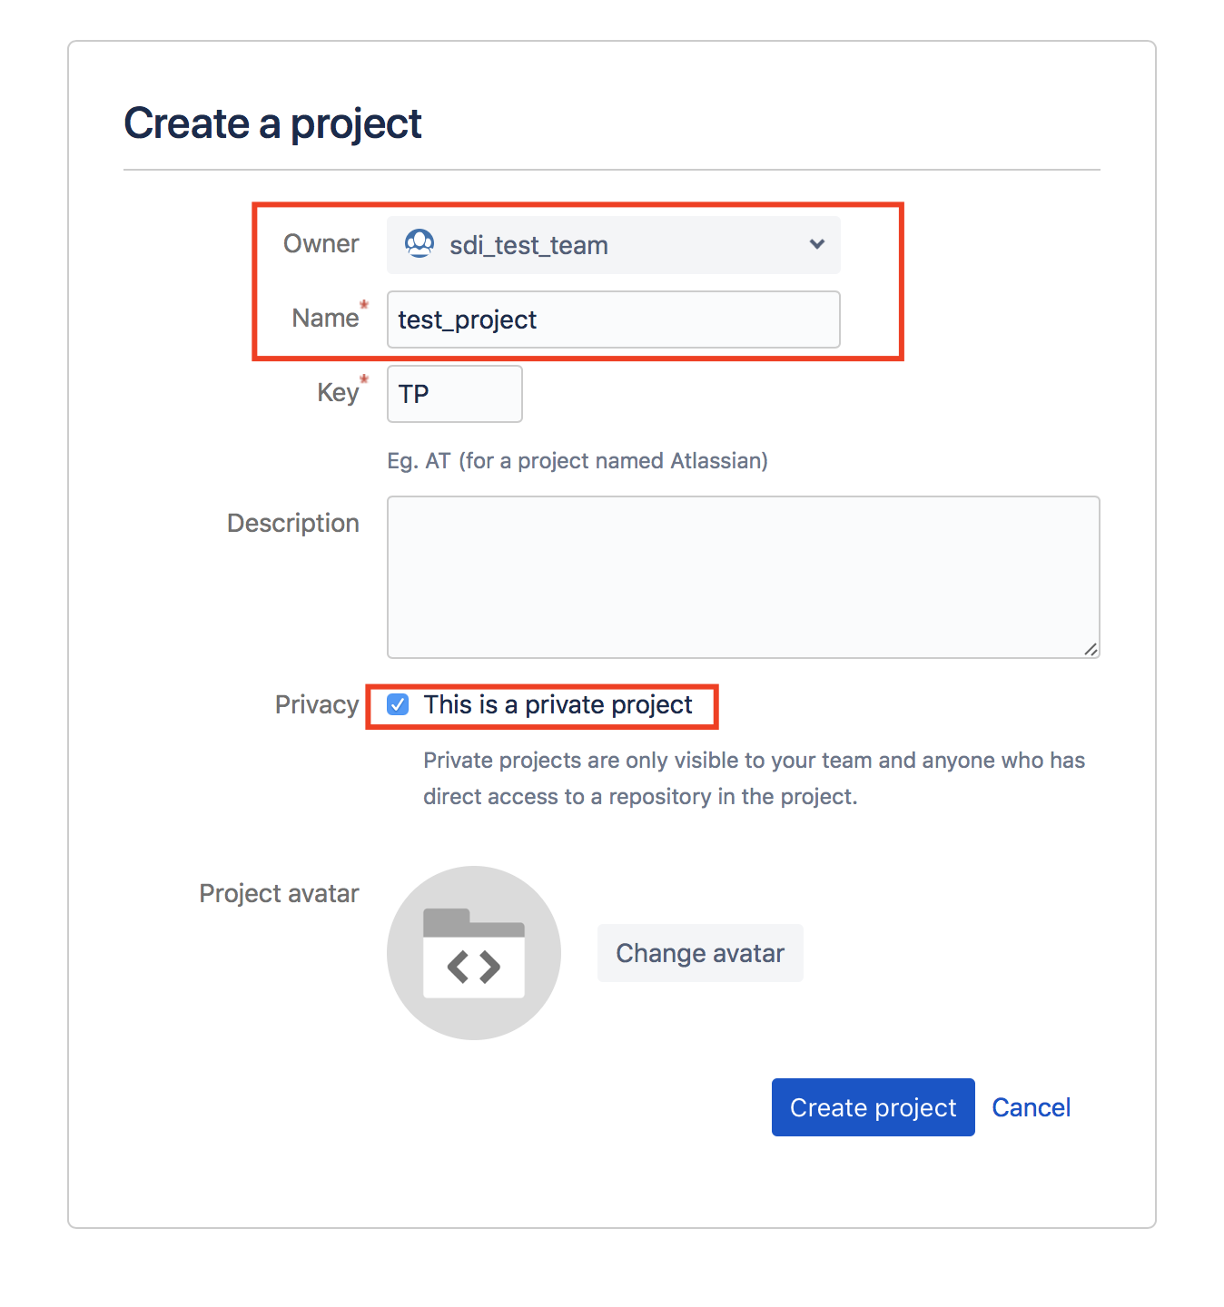

* + create a repository (be sure that in the owner and project dropdowns the correct items are selected; the repository type will be *Git;* be sure that the repository is marked **private**! for repo name I used “test_repo” )

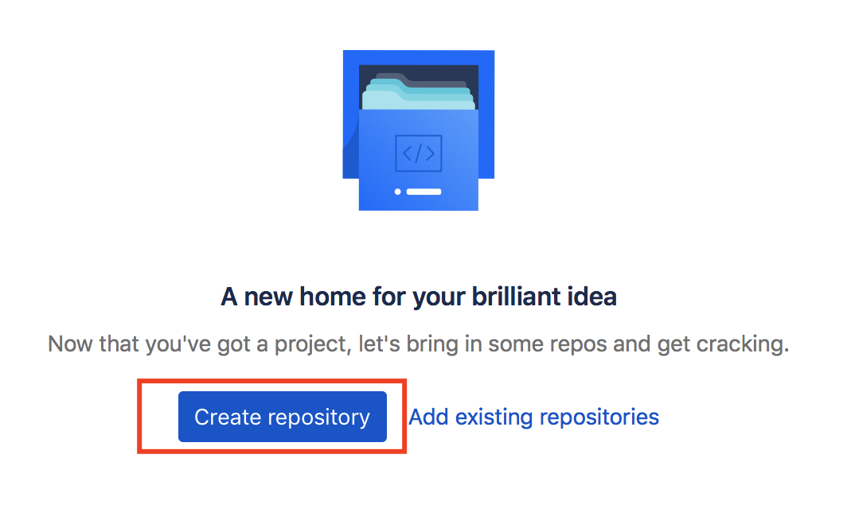

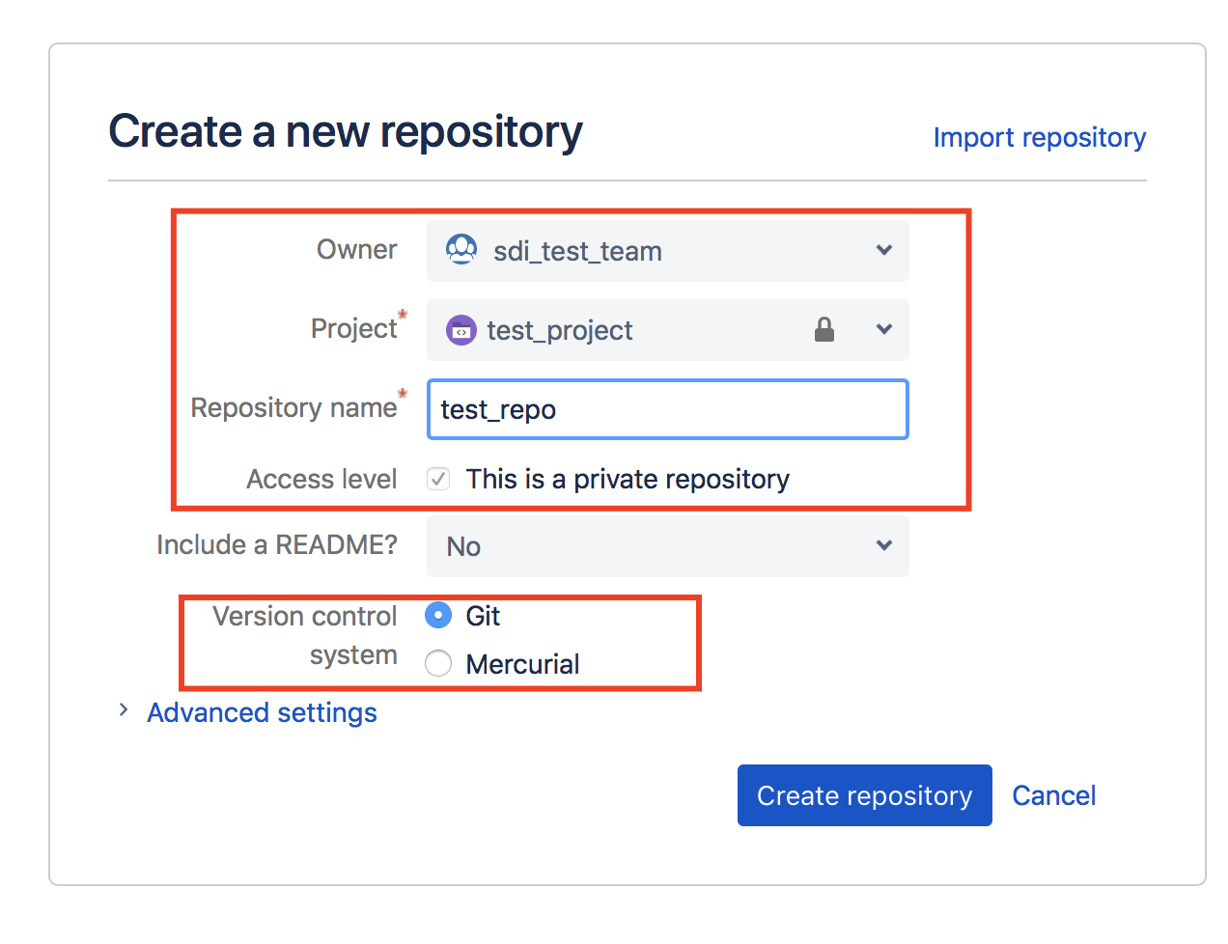

* + You should arrive to a similar screen

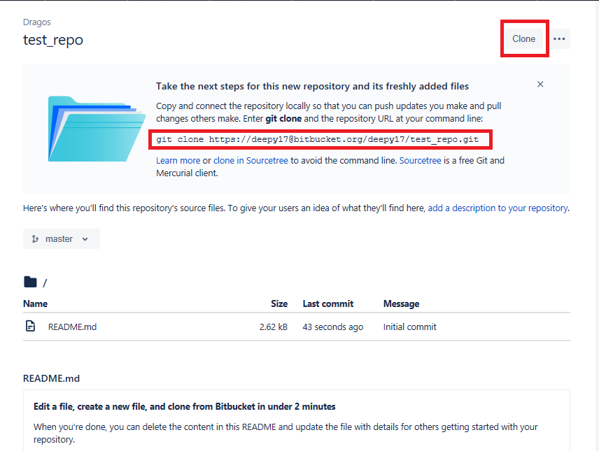

* + - * Click on the **clone** button and take the command from there and paste it in your workspace (or copy it from the marked text; the command should look similar to:

*git clone* [*https://radu1234@bitbucket.org/radu1234/*](https://radu1234@bitbucket.org/radu1234/)*hellogit1**.git*

* + you should now have a *.git* (hidden) folder in your project folder (*hellogit1*)
  + copy the *.gitignore* file from the group in your project folder (*hellogit1*) OR create it from bitbucket and copy the content in it;
  + if the copied file is a Text file named simply “gitignore” or “gitignore.gitignore”, then you have to rename the file by using the following command in the project folder: “mv ./gitignore ./.gitignore” OR “mv ./gitignore.gitignore ./.gitignore”.

*(you can check the name of the file you copied into the folder by using “ls -all”).*

* the student S1 will create a simple hello world java application with IntelliJ IDEA
  + at *project location* select your project folder (e.g: *hellogit1*)
  + the project name will automatically change to the selected folder (e.g: *hellogit1*)
  + be sure that the application runs correctly :)
* the student S1 will “upload” the application to bitbucket
  + in your project folder (e.g: *hellogit1*), at the command line, type the following:
    - *git status*
    - *git add .*
    - *git status*
    - *git commit -m “Some message like created my first hello world java app with git”*
    - *git status*
    - *git push -u origin master*
    - *git status*
* the student S1 will create a branch called “*develop”*

|  |  |
| --- | --- |
|  |  |

* the student S1 will switch to the *develop* branch:
  + *git pull --rebase origin develop*
  + *git checkout develop*

Adding other team members:

* the student S1 will go to the team page (click on the team namelink such as *“sdi_test_team”*)
* Click “Members” on the left -> “Manage team” on the right
* Then add new members by email address:

|  |  |
| --- | --- |
|  |  |

Connecting to the existing repository (the other team member(s) --- S2)

* the student(s) S2 should have received an invitation email from S1
* S2 will perform the indicated steps in order to connect to Bitbucket
* on the repository page you will see the link that needs to be used for cloning
* from the command line, open your workspace directory and execute:

git clone <url>

(for example https://someone@bitbucket.org/sdi_test_team/test_repo.git)

* you should now have a local copy of the repository (*hellogit*) in your workspace
* go to *hellogit and type git checkout develop*
* create a new java project from Intellij IDEA; at project location, select the local repository (*hellogit*)

Start working with git. At the beginning just add new files, do not modify the same file in the same time. Work with: git status, pull, add, commit, push, stash:

* <https://git-scm.com/docs/>
* <https://www.atlassian.com/git/tutorials/setting-up-a-repository/>